**ROAD ACCIDENTS ANALYTICS – SQL QUERIES**

**TOTAL CASUALTIES**

SELECT SUM(number_of_casualties) AS Total_Casualties

FROM road_accidents



**CY CASUALTIES**

SELECT SUM(number_of_casualties) AS CY_Casualties

FROM road_accidents

WHERE YEAR(accident_date) = '2022'



**TOTAL ACCIDENTS**

SELECT COUNT(DISTINCT accident_index) AS TOTAL_ACCIDENTS

FROM road_accidents



**CY ACCIDENTS**

SELECT COUNT(DISTINCT accident_index) AS CY_ACCIDENTS

FROM road_accidents

WHERE YEAR(accident_date) = '2022'



**TOTAL FATAL CASUALTIES**

SELECT SUM( number_of_casualties) AS Total_Fatal_Casualties

FROM road_accidents

WHERE accident_severity = 'Fatal'



**TOTAL FATAL CASUALTIES IN PERCENTAGE**

SELECT CAST(SUM(number_of_casualties) AS DECIMAL(10,2))*100/

(SELECT CAST(SUM(number_of_casualties) AS DECIMAL(10,2)) FROM road_accidents)

AS Fatal_Casualties_Percentage FROM road_accidents

WHERE accident_severity = 'Fatal'



**CY FATAL CASUALTIES**

SELECT SUM( number_of_casualties) AS CY_Fatal_Casualties

FROM road_accidents

WHERE YEAR(accident_date) = '2022' AND accident_severity = 'Fatal'



**TOTAL SERIOUS CASUALTIES**

SELECT SUM( number_of_casualties) AS Total_Serious_Casualties

FROM road_accidents

WHERE accident_severity = 'Serious'



**TOTAL SERIOUS CASUALTIES IN PERCENTAGE**

SELECT CAST(SUM(number_of_casualties) AS DECIMAL(10,2))*100/

(SELECT CAST(SUM(number_of_casualties) AS DECIMAL(10,2)) FROM road_accidents)

AS Serious_Casualties_Percentage FROM road_accidents

WHERE accident_severity = 'Serious'



**CY SERIOUS CASUALTIES**

SELECT SUM( number_of_casualties) AS CY_Serious_Casualties

FROM road_accidents

WHERE YEAR(accident_date) = '2022' AND accident_severity = 'Serious'



**TOTAL SLIGHT CASUALTIES**

SELECT SUM( number_of_casualties) AS Total_Slight_Casualties

FROM road_accidents

WHERE accident_severity = 'Slight'



**TOTAL SLIGHT CASUALTIES IN PERCENTAGE**

SELECT CAST(SUM(number_of_casualties) AS DECIMAL(10,2))*100/

(SELECT CAST(SUM(number_of_casualties) AS DECIMAL(10,2)) FROM road_accidents)

AS Slight_Casualties_Percentage FROM road_accidents

WHERE accident_severity = 'Slight'



**CY SLIGHT CASUALTIES**

SELECT SUM( number_of_casualties) AS CY_Slight_Casualties

FROM road_accidents

WHERE YEAR(accident_date) = '2022' AND accident_severity = 'Slight'



**TOTAL CASUALTIES BY VEHICLE TYPE**

SELECT

CASE

WHEN vehicle_type IN ('Agricultural vehicle') THEN 'Agricultural'

WHEN vehicle_type IN ('Taxi/Private hire car','Car') THEN 'Cars'

WHEN vehicle_type IN ('Motorcycle over 500cc','Motorcycle 125cc

and under','Motorcycle 50cc and under',

'Motorcycle over 125cc and up to 500cc')

THEN 'Bike'

WHEN vehicle_type IN ('Bus or coach (17 or more pass seats)',

'Minibus (8 - 16 passenger seats)') THEN 'Bus'

WHEN vehicle_type IN ('Van / Goods 3.5 tonnes mgw or under',

'Goods over 3.5t. and under 7.5t',

'Goods 7.5 tonnes mgw and over') THEN 'Van'

ELSE 'Others'

END AS vehicle_group,

SUM(number_of_casualties) AS Total_Casualties

FROM road_accidents

GROUP BY

CASE

WHEN vehicle_type IN ('Agricultural vehicle') THEN 'Agricultural'

WHEN vehicle_type IN ('Taxi/Private hire car','Car') THEN 'Cars'

WHEN vehicle_type IN ('Motorcycle over 500cc','Motorcycle 125cc

and under','Motorcycle 50cc and under',

'Motorcycle over 125cc and up to 500cc')

THEN 'Bike'

WHEN vehicle_type IN ('Bus or coach (17 or more pass seats)',

'Minibus (8 - 16 passenger seats)') THEN 'Bus'

WHEN vehicle_type IN ('Van / Goods 3.5 tonnes mgw or under',

'Goods over 3.5t. and under 7.5t',

'Goods 7.5 tonnes mgw and over') THEN 'Van'

ELSE 'Others'

END

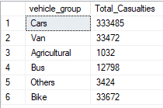

**CY CASUALTIES BY VEHICLE TYPE**

SELECT

CASE

WHEN vehicle_type IN ('Agricultural vehicle') THEN 'Agricultural'

WHEN vehicle_type IN ('Taxi/Private hire car','Car') THEN 'Cars'

WHEN vehicle_type IN ('Motorcycle over 500cc','Motorcycle 125cc

and under','Motorcycle 50cc and under',

'Motorcycle over 125cc and up to 500cc')

THEN 'Bike'

WHEN vehicle_type IN ('Bus or coach (17 or more pass seats)',

'Minibus (8 - 16 passenger seats)')

THEN 'Bus'

WHEN vehicle_type IN ('Van / Goods 3.5 tonnes mgw or under',

'Goods over 3.5t. and under 7.5t',

'Goods 7.5 tonnes mgw and over')

THEN 'Van'

ELSE 'Others'

END AS vehicle_group,

SUM (number_of_casualties) AS Total_Casualties

FROM road_accidents

WHERE YEAR(accident_date) = '2022'

GROUP BY

WHEN vehicle_type IN ('Agricultural vehicle') THEN 'Agricultural'

WHEN vehicle_type IN ('Taxi/Private hire car','Car') THEN 'Cars'

WHEN vehicle_type IN ('Motorcycle over 500cc','Motorcycle 125cc

and under','Motorcycle 50cc and under',

'Motorcycle over 125cc and up to 500cc')

THEN 'Bike'

WHEN vehicle_type IN ('Bus or coach (17 or more pass seats)',

'Minibus (8 - 16 passenger seats)')

THEN 'Bus'

WHEN vehicle_type IN ('Van / Goods 3.5 tonnes mgw or under',

'Goods over 3.5t. and under 7.5t',

'Goods 7.5 tonnes mgw and over')

THEN 'Van'

ELSE 'Others'

END

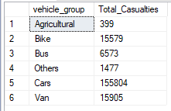

**MONTHLY TREND OF CY CASUALTIES (2022)**

SELECT DATENAME(MONTH, accident_date) AS Month_Name, SUM(number_of_casualties) AS CY_CASUALTIES

FROM road_accidents

WHERE YEAR(accident_date) = '2022'

GROUP BY DATENAME(MONTH, accident_date)

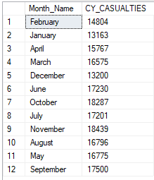

**MONTHLY TREND OF LAST YEAR CASUALTIES (2021)**

SELECT DATENAME(MONTH, accident_date) AS Month_Name, SUM(number_of_casualties) AS LY_CASUALTIES

FROM road_accidents

WHERE YEAR(accident_date) = '2021'

GROUP BY DATENAME(MONTH, accident_date)

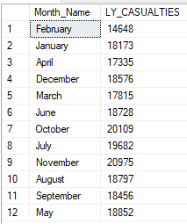

**TOTAL CASUALTIES BY ROAD TYPE**

SELECT road_type, SUM(number_of_casualties) AS Total_Casualties

FROM road_accidents

GROUP BY road_type

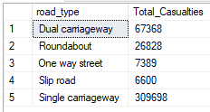

**CY CASUALTIES BY ROAD TYPE**

SELECT road_type, SUM(number_of_casualties) AS CY_Casualties

FROM road_accidents

WHERE YEAR(accident_date) = '2022'

GROUP BY road_type

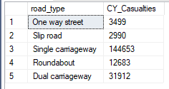

**TOTAL CASUALTIES BY AREA(URBAN/RURAL)**

SELECT urban_or_rural_area, SUM(number_of_casualties) AS

Total_Casualties

FROM road_accidents

GROUP BY urban_or_rural_area

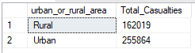

**TOTAL CASUALTIES BY AREA IN PERCENTAGE**

SELECT urban_or_rural_area, CAST(SUM(number_of_casualties) AS DECIMAL (10,2)) * 100/

(SELECT CAST(SUM(number_of_casualties) AS DECIMAL (10,2)) FROM road_accidents)

AS Total_Casualties_in_Percentage

FROM road_accidents

GROUP BY urban_or_rural_area

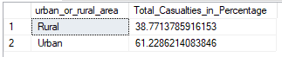

**CY CASUALTIES BY AREA(URBAN/RURAL)**

SELECT urban_or_rural_area, SUM(number_of_casualties) AS

CY_Casualties

FROM road_accidents

WHERE YEAR(accident_date) = '2022'

GROUP BY urban_or_rural_area

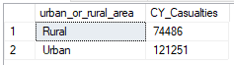

**CY CASUALTIES BY AREA IN PERCENTAGE**

SELECT urban_or_rural_area, CAST(SUM(number_of_casualties) AS DECIMAL (10,2)) * 100/

(SELECT CAST(SUM(number_of_casualties) AS DECIMAL (10,2)) FROM road_accidents

WHERE YEAR(accident_date) ='2022') AS CY_Casualties_in_Percentage

FROM road_accidents

WHERE YEAR(accident_date)='2022'

GROUP BY urban_or_rural_area

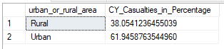

**TOTAL CASUALTIES BY LIGHT CONDITIONS**

SELECT

CASE

WHEN light_conditions IN ('Darkness - lights lit','Darkness –

lighting unknown','Darkness -

lights unlit','Darkness – no

lighting')

THEN 'Dark'

ELSE 'Daylight'

END AS light_conditions_group,

SUM(number_of_casualties) AS Total_Casualties

FROM road_accidents

GROUP BY

CASE

WHEN light_conditions IN ('Darkness - lights lit','Darkness –

lighting unknown','Darkness -

lights unlit','Darkness – no

lighting')

THEN 'Dark'

ELSE 'Daylight'

END

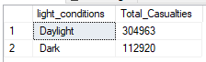

**CY CASUALTIES BY LIGHT CONDITIONS**

SELECT

CASE

WHEN light_conditions IN ('Darkness - lights lit','Darkness –

lighting unknown','Darkness -

lights unlit','Darkness – no

lighting')

THEN 'Dark'

ELSE 'Daylight'

END AS light_conditions_group,

SUM(number_of_casualties) AS CY_Casualties

FROM road_accidents

WHERE YEAR(accident_date) = '2022'

GROUP BY

CASE

WHEN light_conditions IN ('Darkness - lights lit','Darkness –

lighting unknown','Darkness -

lights unlit','Darkness – no

lighting')

THEN 'Dark'

ELSE 'Daylight'

END

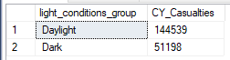

**TOTAL CASUALTIES BY ROAD SURFACE**

SELECT

CASE

WHEN road_surface_conditions IN ('Dry') THEN 'Dry'

WHEN road_surface_conditions IN ('Frost or ice','Snow') THEN 'Frost/Snow'

WHEN road_surface_conditions IN ('Wet or damp','Flood over 3cm. deep') THEN 'Wet'

ELSE '(Blank)'

END AS road_surface_conditions,

SUM(number_of_casualties) AS Total_Casualties

FROM road_accidents

GROUP BY

CASE

WHEN road_surface_conditions IN ('Dry') THEN 'Dry'

WHEN road_surface_conditions IN ('Frost or ice', 'Snow') THEN 'Frost/Snow'

WHEN road_surface_conditions IN ('Wet or damp','Flood over 3cm. deep') THEN 'Wet'

ELSE '(Blank)'

END

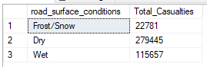

**CY CASUALTIES BY ROAD SURFACE**

SELECT

CASE

WHEN road_surface_conditions IN ('Dry') THEN 'Dry'

WHEN road_surface_conditions IN ('Frost or ice','Snow') THEN 'Frost/Snow'

WHEN road_surface_conditions IN ('Wet or damp','Flood over 3cm. deep') THEN 'Wet'

ELSE '(Blank)'

END AS road_surface_conditions,

SUM(number_of_casualties) AS Total_Casualties

FROM road_accidents

WHERE YEAR(accident_date) = '2022'

GROUP BY

CASE

WHEN road_surface_conditions IN ('Dry') THEN 'Dry'

WHEN road_surface_conditions IN ('Frost or ice', 'Snow') THEN 'Frost/Snow'

WHEN road_surface_conditions IN ('Wet or damp','Flood over 3cm. deep') THEN 'Wet'

ELSE '(Blank)'

END

